STOCKPORT COLLEGE
TRADE UNION EDUCATION UNIT
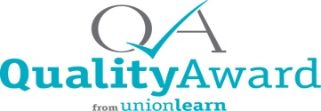

UNDERSTANDING PUBLIC SECTOR PENSIONS
The Local Government Pension Scheme
A Free, Accredited, Distance Learning Course
for Unison members as students of Stockport College
This course aims to help you:

- Understand different types of pension schemes
- Understand state and occupational pension schemes
- Understand your own pension scheme
- Understand how to improve your pension
- Answer your pension questions

The course has two component parts:
- A course book to read (with supporting handouts and internet links)
- A question booklet and a second set of questions to complete within a 2 week period. You work in your own time and at your own pace. There are no online meetings.

To start the course, you will need to complete a number of forms: 1) a College enrolment form 2) a course registration form for the tutor.
The course will be supported on email by DAVE McMONNIES your pension’s tutor and you will be able to ask your own specific questions and get a personalised answer.
To enquire about enrolling on the course please email:
pensioneducationtraining@gmail.com
To complete the course, you will need:
a) easy access to email
b) ability to download Microsoft WORD documents (like this flyer)

