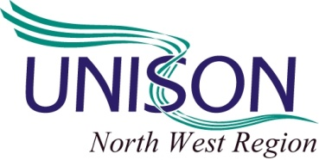

EMERGENCY MOTION
Regional Committee AGM 15th July 2014

Gaza under attack

UNISON North West region condemns the massacre of the people of Gaza and the ongoing destruction of Palestinian land by the Israeli state since 8 July 2014. To date over 200 people have been killed the overwhelming majority women and children. The Israeli military action is a deliberate act to terrorise the population and destroy the country's already fragile infrastructure.

These actions are in clear breach of International Law and amount to war crimes against humanity.

UNISON North West region calls for:

1 The UK government to condemn the indiscriminate killing by Israeli forces. The Prime Minister and Foreign Secretary must demand that the United Nations Security Council call for an immediate ceasefire. Further the Security Council should carry out an urgent investigation into Israel's actions with a view to introducing tough sanctions and other appropriate action if it is shown that International Law has been broken.

2 Branches and members to write to local MP’s asking they condemn Israel's aggression and call for immediate action from the UK government.

3 Branches and members to support demonstrations locally, regionally and nationally called by the Palestine Solidarity Campaign.

4 Welcomes UNISON’s National Executive Council statement on the situation in Gaza.

Finally, UNISON North West region pledges to donate £1000 to Medical Aid for Palestinians (MAP) and calls on branches to contribute to the MAP emergency appeal for Gaza.

Submitted by Regional Secretariat Group

